**Electronic supplementary information**

**SYNTHESIS AND STRUCTURE  
OF [Sb(μ2-O)Cl(DMSO-О)]n**

I. V. Egorova,*\*a* I. N. Nesina,*a* V. V. Zhidkov,*a* N. A. Rodionova,*a*N. V. Kuratieva,*b* and N. V. Pervukhina*b*

a Blagoveshchensk State Pedagogical University,  
Blagoveshchensk, ul. Lenina 104, 675004 Russia

*b Nikolaev Institute of Inorganic Chemistry, Siberian Branch of the Russian Academy  
of Sciences, pr. Akademika Lavrent'eva 3, Novosibirsk, 630090 Russia*

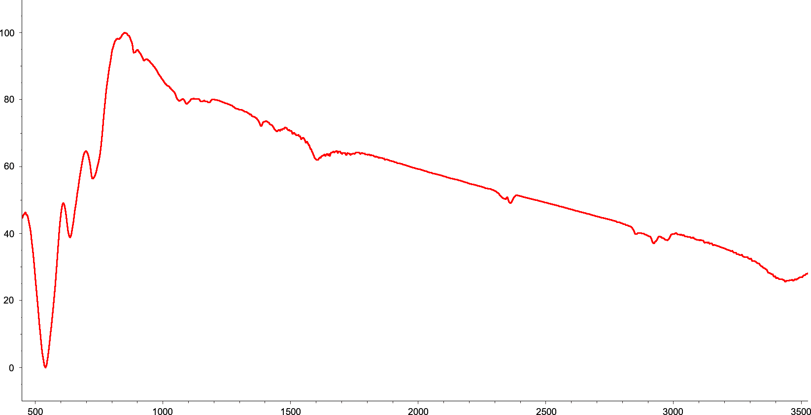

**Figure S1.** IR spectrum of SbOCl.

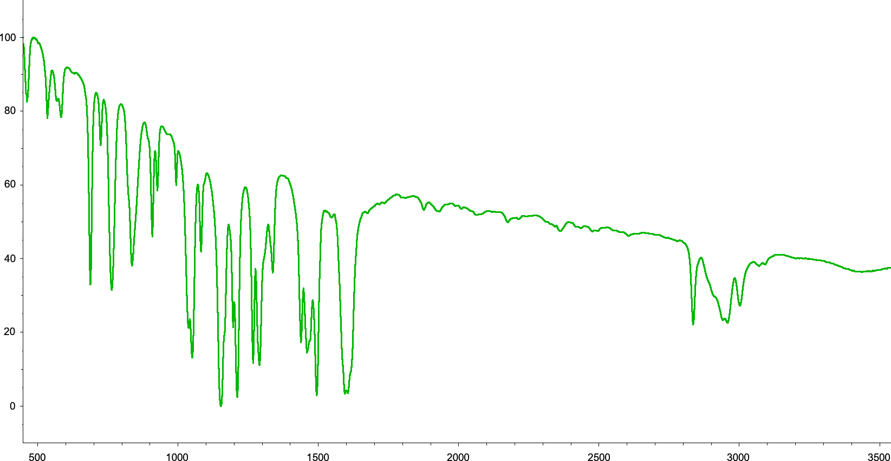

**Figure S2.** IR spectrum of *m*-dimethoxybenzene.

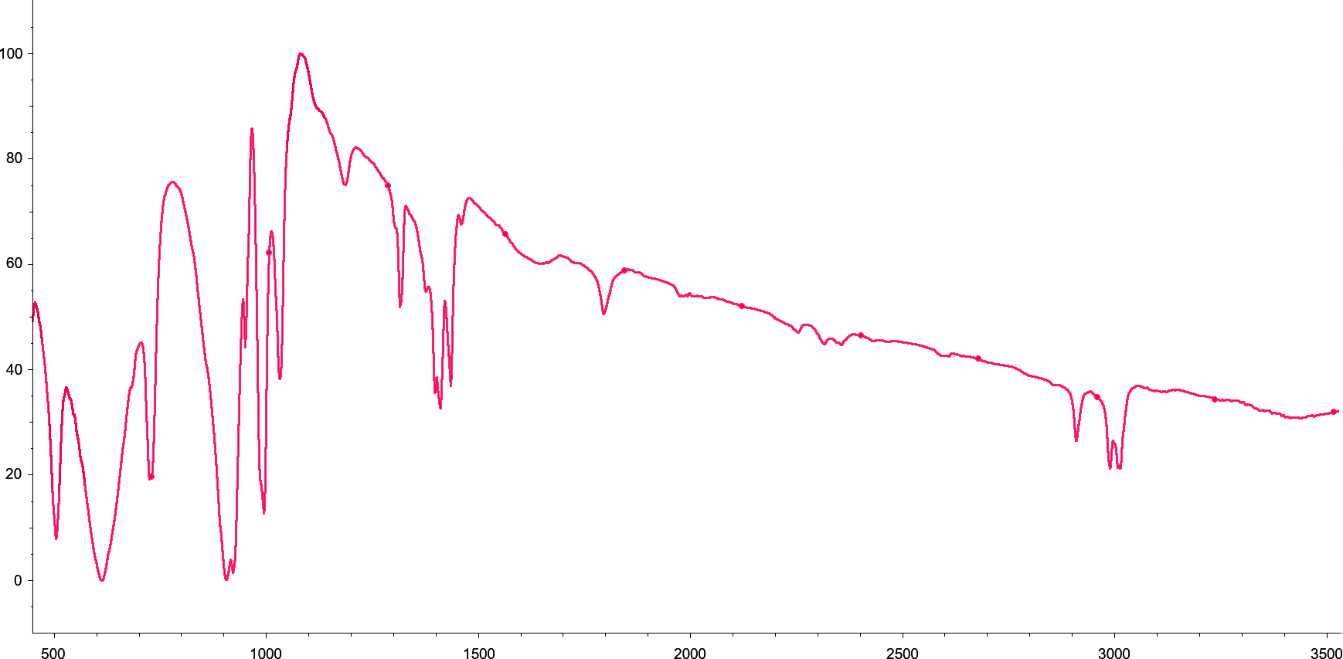

**Figure S3.** IR spectrum of [Sb(μ2-O)Cl(DMSO-О)]n.